
NORTHERN EDUCATION DIVISION
2025 MSCE MOCK EXAMINATION
ADDITIONAL MATHEMATICS
PAPER I
Tuesday, 25 March. (100 marks) Subject Number: M132/I.
Time Allowed: 2hours 30 min.
(8:00-10:30) am.
Question number | Tick if answered | Do not write in these columns
1
2
3
4
5
6
7
8
9
10
 | Total
Instructions:
- This paper contains 15 pages. Please check.
- Answer all 7 questions in section A and any two questions in section B.
- Section A carries 60 marks and section B carries 40 marks
- The maximum number of marks for each answer is indicated against each question.
- Write your answers in the spaces provided on the question paper
- Calculators may be used.
- All working must be clearly shown.
- Write your name at the top of each page on your question paper in the spaces provided.
- In the table provided on this page, tick against the question number you have answered.

Section A (60 marks)
Answer all the seven questions from this section.
- a. Given that $f\left(x\right)=2x+1$ and $g\left(x\right)=4x^{2},$ $gf^{-1}\left(-2\right)$ (4 marks)

- A sector of a circle of radius 12 cm and area 150 cm², is folded up to form a cone. Calculate the radius of a cone. (4 marks)

- Find the constant term in the expansion of ${\left(2x-\frac{1}{x}\right)}^{10}$. (6 marks)

- Solve the equation$tanϑ=2cosϑ$, for $0^{0} ≤ϑ ≤{180}^{0}.$ (6 marks)

- Solve the inequality: $x-\frac{1}{4}x^{3}$ < 0 (6 marks)

- a. Show that $\tan^{2}ϑ≡\sin^{2}θ+\tan^{2}θ\sin^{2}θ.$ (5marks)

- Evaluate: $\int{\frac{x^{2}}{\sqrt{1+x^{3}}} }dx.$ (4 marks)

- a. A spherical balloon is inflated. When the diameter is 10 cm, its volume increases at a rate of 200 cm³/s. At what rate does its surface area increases? Give the answer in terms of $π.$ (6 marks)

b. Figure 1 below shows the variables $x$ and $y$ that are related by the equation $x$+$\frac{t}{x}$ $=vy$ where $t$ and $v$ are constants. A straight-line graph is obtained as shown below.
$xy$
(6,3)

(4,0) $x^{2}$

Figure 1.
Find the values of $t$ and $v.$ (4 marks)

- a. The resistance of a wire R is related to its diameter d through the formula $R= \frac{a}{d^{2 }}+b$ where a and b are constants. The following data was obtained through an experiment in a chemistry lab.
d mm | 1.95 | 1.8 | 1.6 | 1.5 | 1.2 | 0.9
R ohms | 1.92 | 2.08 | 2.37 | 2.56 | 3.43 | 5.32

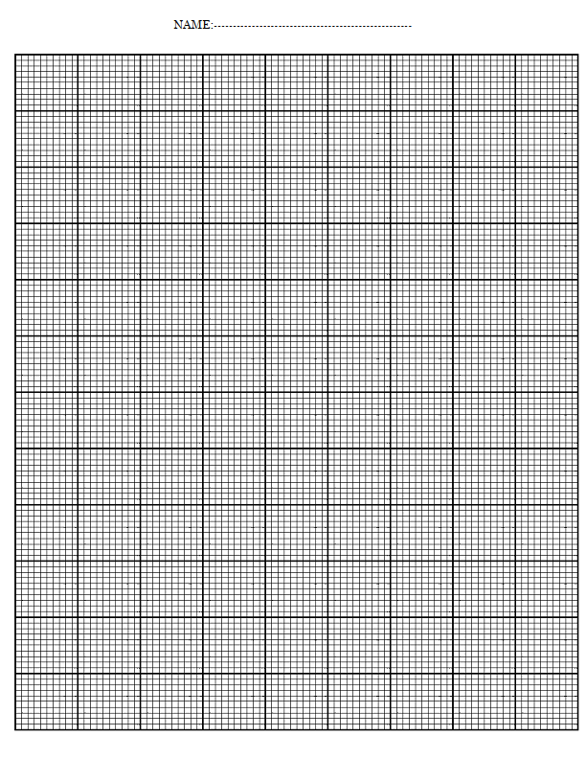

Find the values of a and b. (8 marks)

- The length of a closed rectangular box is 3 times its width. If its volume is $972 {cm}^{3}$. Calculate the dimensions of the box that makes its surface a minimum. (8 marks)

Section B (40 Marks)
Answer any two questions from this section.
- a. A cylindrical can (with lid) of radius $r cm$ is made from $300{cm}^{2}$ of thin sheet metal.

- Show that its height $h cm$ is given by $h$ $= \frac{150- πr^{2}}{πr}.$ (4marks)

- Find $r$ and $h$ so that the can will contain the maximum possible volume and find this volume. (6 marks)

- Given that the first three terms in the expansion of$\left(p+qx\right){\left(1-3x\right)}^{5}$ are $3+rx+300x^{2},$ find the values of $p, q$ and $r.$ (10 marks)

- a. Figure 2 below shows part of the curve $y=sinx+sin2x.$

y

2
1
A x
$y=sinx+sin2x$

- find the coordinates of point A. (4 marks)

- find the area of shaded region. (6 marks)

- By sketching, solve the inequality: $y<$ $\frac{x-2}{3x+2}.$ (10 marks)

- a. Using a scale of 2cm to represent $\frac{π}{6}$ on the horizontal axis and 2cm to represent 1 unit on the vertical axis.

- Draw the graph of $y=3sinx+2cosx$ for $0 ≤x ≤ π$ (5 marks)


- Use the graph to solve the equation $6 sinx+4 cosx=7.$ (4 marks)

- Find the maximum value on the graph $y=3sinx+2cosx.$ (3 marks)

b. Find the range of values of $x$ for which $- \frac{4}{x}$ $>-3$. (8 marks)

END OF QUESTION PAPER
NOTE: This paper contains 15 printed pages.

